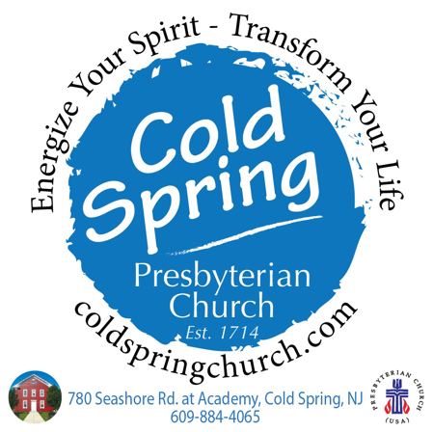
My Worship Notes

Date: ______________________________________

Pastor Kevin’s
Sermon Title: _______________________________

Scripture Text: ______________________________

Music: _____________________________________

Special Music: ______________________________

Conversations, Experiences, and Discoveries
(Music, Words, Prayers, Scripture, that meant a lot to me.)

My Take-Away
(I will put the following into practice during the week.)

My Give-Away
(What I will share the following with others this week.)

